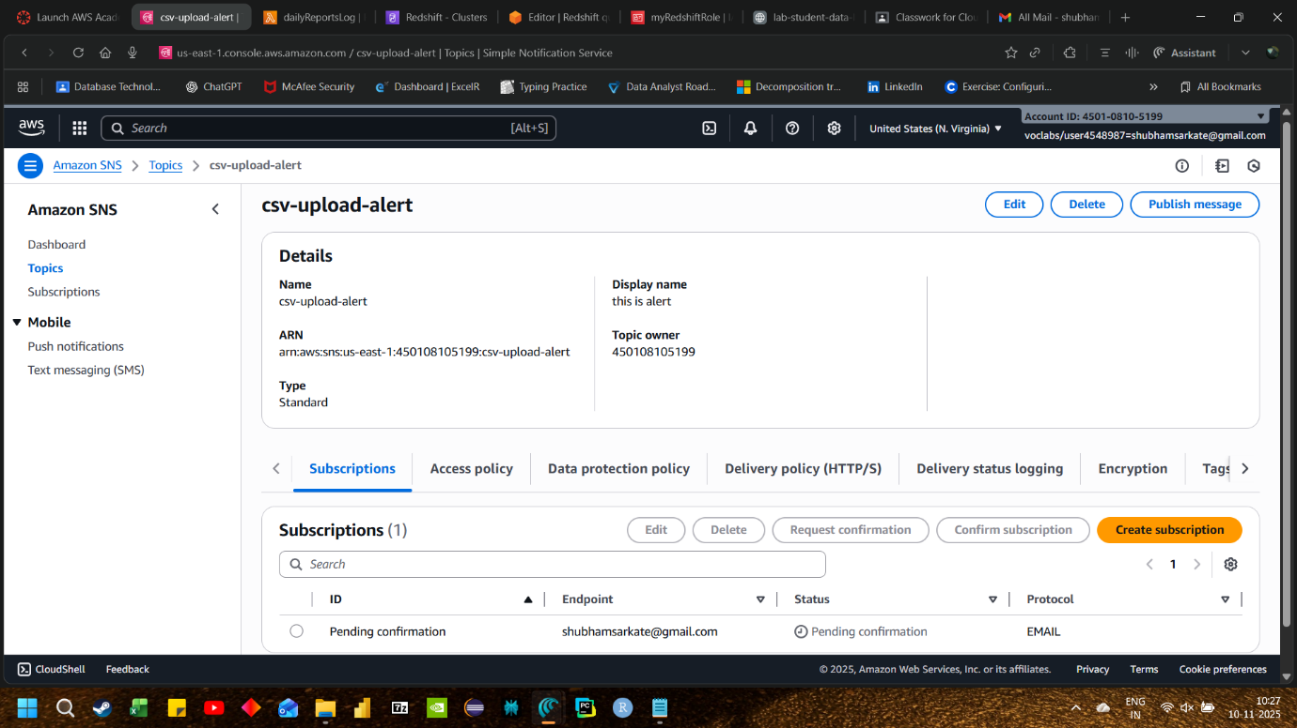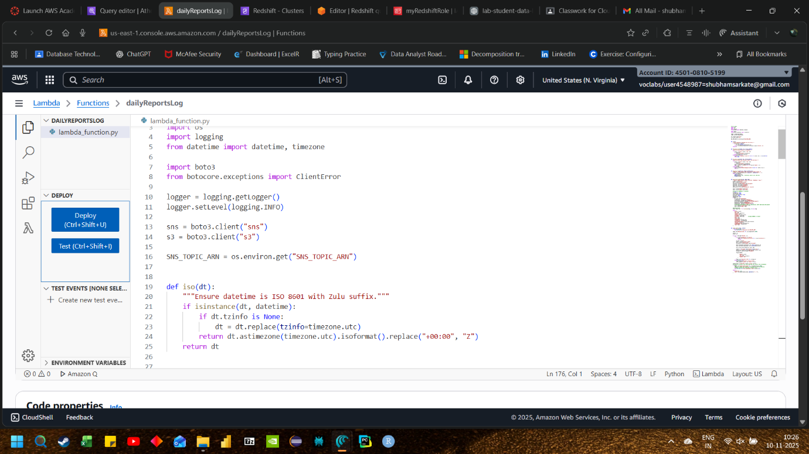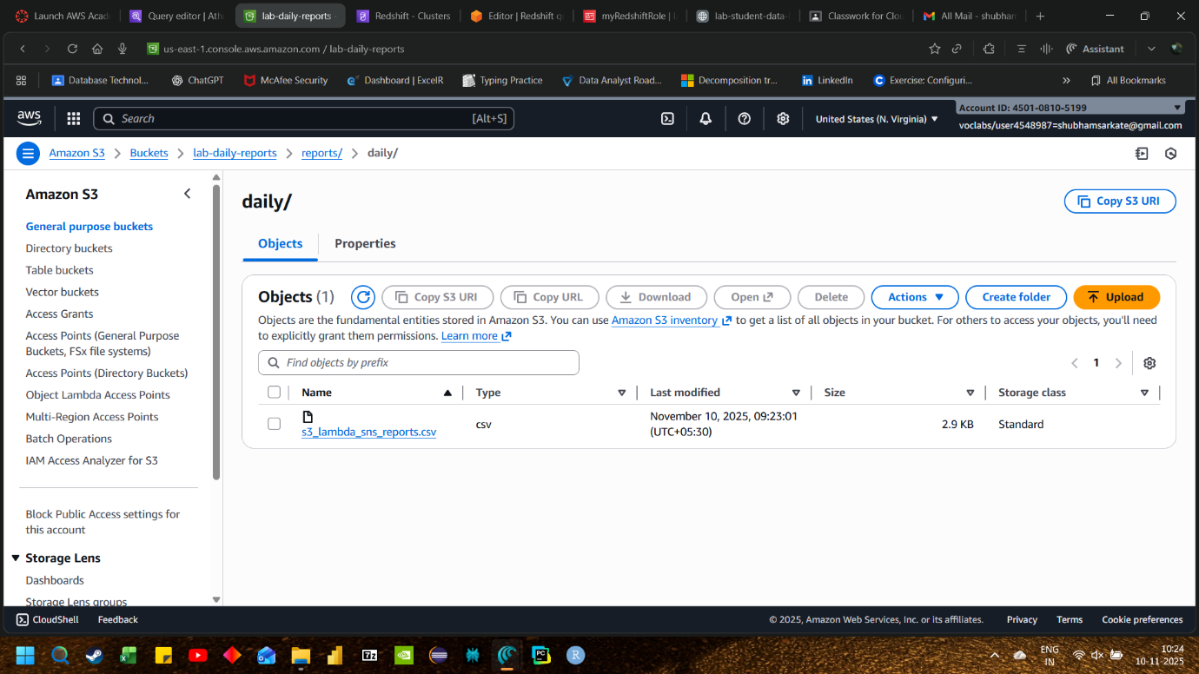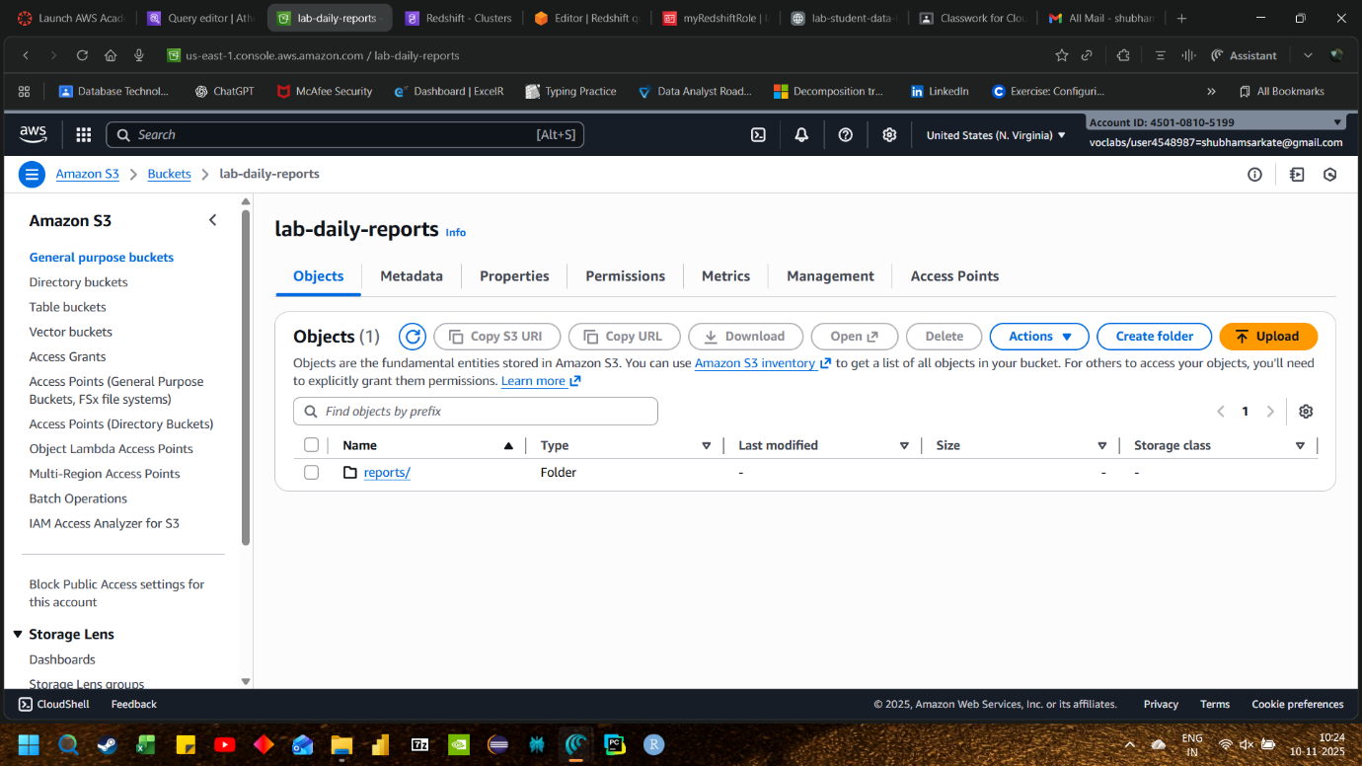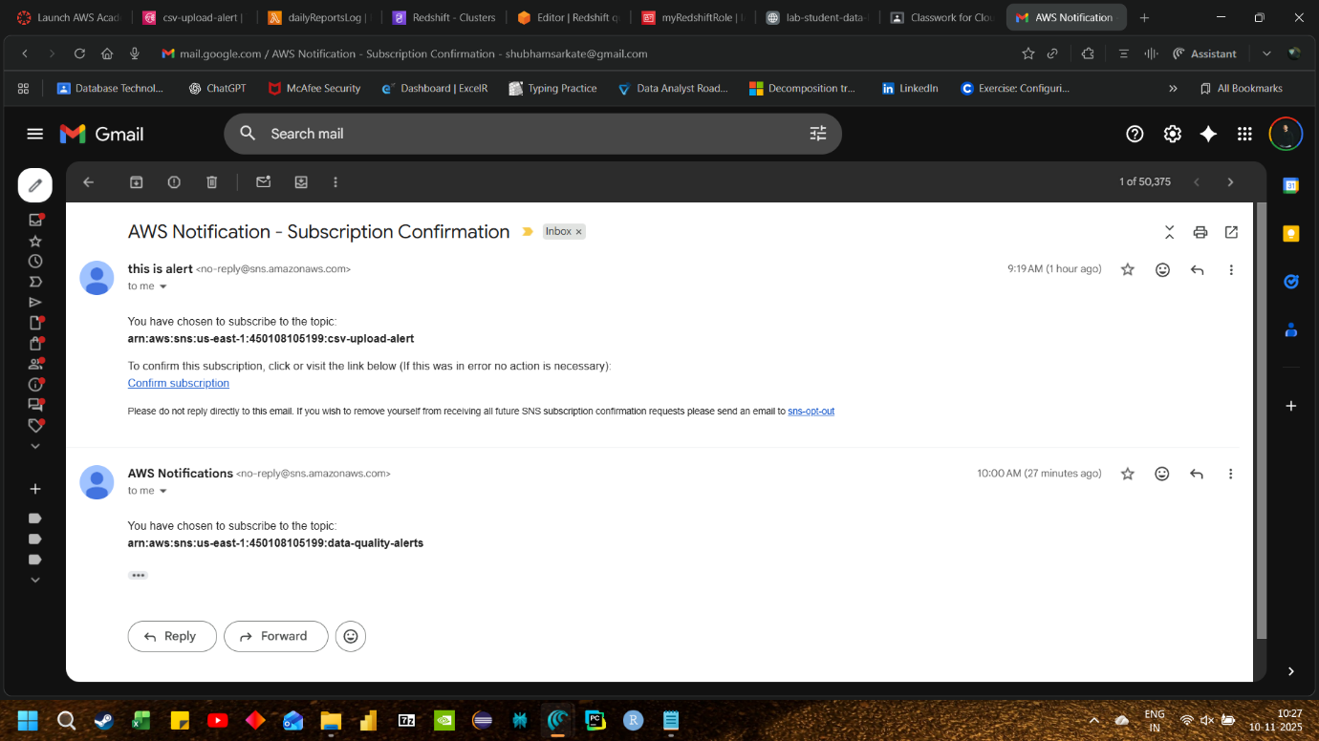

2.quetion code

# file: app.py
import json
import os
import logging
from datetime import datetime, timezone

import boto3
from botocore.exceptions import ClientError

logger = logging.getLogger()
logger.setLevel(logging.INFO)

sns = boto3.client("sns")
s3 = boto3.client("s3")

SNS_TOPIC_ARN = os.environ.get("SNS_TOPIC_ARN")

def iso(dt):
"""Ensure datetime is ISO 8601 with Zulu suffix."""
if isinstance(dt, datetime):
if dt.tzinfo is None:
dt = dt.replace(tzinfo=timezone.utc)
return dt.astimezone(timezone.utc).isoformat().replace("+00:00", "Z")
return dt

def head_object_safe(bucket, key, version_id=None):
"""Fetch S3 object metadata via HeadObject."""
try:
kwargs = {"Bucket": bucket, "Key": key}
if version_id:
kwargs["VersionId"] = version_id
return s3.head_object(**kwargs)
except ClientError as e:
logger.error("HeadObject failed for %s/%s: %s", bucket, key, e, exc_info=True)
return None

def get_object_tags(bucket, key, version_id=None):
"""Fetch S3 object tags (optional; doesn't fail the flow)."""
try:
kwargs = {"Bucket": bucket, "Key": key}
if version_id:
kwargs["VersionId"] = version_id
resp = s3.get_object_tagging(**kwargs)
tags = {t["Key"]: t["Value"] for t in resp.get("TagSet", [])}
return tags
except ClientError as e:
logger.warning("GetObjectTagging failed for %s/%s: %s", bucket, key, e)
return {}

def publish_to_sns(topic_arn, subject, payload_dict):
"""Publish a JSON payload to SNS with an email-friendly subject."""
message = json.dumps(payload_dict, default=str, separators=(",", ":"))
return sns.publish(
TopicArn=topic_arn,
Subject=subject[:100], # SNS email subject limit ~100 chars
Message=message,
)

def build_record_summary(ev_rec, head, tags):
"""Build a compact metadata summary from event + HeadObject + tags."""
s3_info = ev_rec["s3"]
bucket = s3_info["bucket"]["name"]
key = s3_info["object"]["key"]
version_id = s3_info["object"].get("versionId")
event_time = ev_rec.get("eventTime")
event_name = ev_rec.get("eventName")
region = ev_rec.get("awsRegion")
event_source = ev_rec.get("eventSource", "aws:s3")

size = s3_info["object"].get("size")
etag = s3_info["object"].get("eTag")

# Enrich from HeadObject if available
ct = None
storage_class = None
last_modified = None
server_side_encryption = None
kms_key_id = None
checksum_algo = None
metadata_user = {}
if head:
ct = head.get("ContentType")
storage_class = head.get("StorageClass")
last_modified = iso(head.get("LastModified"))
server_side_encryption = head.get("ServerSideEncryption")
kms_key_id = head.get("SSEKMSKeyId")
checksum_algo = head.get("ChecksumAlgorithm")
metadata_user = head.get("Metadata", {}) or {}
# size/etag may be absent in event for some sources; prefer head values when present
size = head.get("ContentLength", size)
etag = head.get("ETag", etag)

# Normalize/clean
etag = etag.strip('"') if isinstance(etag, str) else etag

return {
"bucket": bucket,
"key": key,
"versionId": version_id,
"region": region,
"eventSource": event_source,
"eventName": event_name,
"eventTime": event_time, # already ISO8601 in S3 event
"size": size,
"eTag": etag,
"contentType": ct,
"storageClass": storage_class,
"lastModified": last_modified,
"serverSideEncryption": server_side_encryption,
"kmsKeyId": kms_key_id,
"checksumAlgorithm": checksum_algo,
"userMetadata": metadata_user,
"tags": tags,
}

def lambda_handler(event, context):
if not SNS_TOPIC_ARN:
raise RuntimeError("Missing env var SNS_TOPIC_ARN")

logger.info("Received event: %s", json.dumps(event)[:2000])

results = []
errors = []

for rec in event.get("Records", []):
try:
if rec.get("eventSource") != "aws:s3":
logger.info("Skipping non-S3 record: %s", rec.get("eventSource"))
continue

s3_info = rec["s3"]
bucket = s3_info["bucket"]["name"]
key = s3_info["object"]["key"]
version_id = s3_info["object"].get("versionId")

head = head_object_safe(bucket, key, version_id=version_id)
tags = get_object_tags(bucket, key, version_id=version_id)

meta = build_record_summary(rec, head, tags)

subject = f"S3 upload: {meta['bucket']}/{meta['key']}"
publish_resp = publish_to_sns(SNS_TOPIC_ARN, subject, meta)
message_id = publish_resp.get("MessageId")

results.append(
{
"bucket": bucket,
"key": key,
"messageId": message_id,
"status": "OK",
}
)
logger.info("Published to SNS: %s", message_id)
except Exception as e:
logger.exception("Failed to process record")
errors.append({"record": rec, "error": str(e)})

response_body = {"published": results, "errors": errors}
# If any error occurred, still return 207-like info; S3 will retry on exception.
if errors:
logger.error("Some records failed: %s", json.dumps(errors)[:1000])
# Raise to trigger retry semantics if you prefer at-least-once delivery
# Comment the next line if you want to swallow errors.
raise RuntimeError(f"Errors publishing to SNS: {len(errors)}")

return {
"statusCode": 200,
"body": json.dumps(response_body, separators=(",", ":")),
}

